**FOR IMMEDIATE RELEASE**

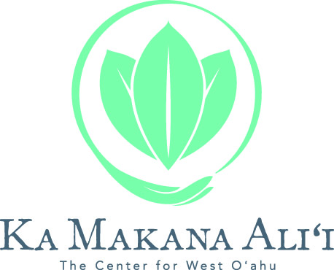

**KA MAKANA ALII WELCOMES GUESTS WITH HOLIDAY FESTIVITIES AND THE SPRING SALE CELEBRATION DURING THE MONTH OF APRIL**

**KAPOLEI, HAWAI‘I (APRIL 12, 2017)** – Ka Makana Ali‘i invites visitors and residents of West O‘ahu to the center for the month of April with Easter celebrations and an exciting Spring Sale Celebration.

It’s not too late for lucky keiki to hop over to the center for a picture with the world’s most magical bunny. The Easter Bunny will be posing for the Easter Bunny Photo Set through to Saturday, April 15. Visit [www.kamakanaalii.com/events](http://www.kamakanaalii.com/events) for special Easter hours for select retailers and restaurants.

Nothing says spring like a sidewalk sale, and Ka Makana Ali’i is pleased to welcome guests and visitors to West O‘ahu for the Spring Sale Celebration taking place from Friday, April 21, to Sunday, April 23. For one weekend only, shoppers will enjoy spring sales across the center, with a seasonal sidewalk sale and entertainment all weekend long. Shoppers can also enter-to-win a $300 Ka Makana Ali’i gift card at the new Red Pineapple located near Macy’s.

**Holiday Hours:**

* Friday, April 14 — 10:00am - 9:00pm
* Saturday, April 15 — 10:00am - 9:00pm
* Sunday, April 16 — *see www.kamakanaalii.com/events for special Easter hours for select retailers and restaurants*

Visit our website at [www.kamakanaalii.com/events](http://www.kamakanaalii.com/events) for more details about events taking place during the month of April. For the latest news and updates follow Ka Makana Ali‘i on Facebook at [https://www.facebook.com/kamakanaAli‘i/](http://anthology.pr-optout.com/Tracking.aspx?Data=HHL%3d82%3a1%3b0-%3eLCE58%2f7%2f%3a%26SDG%3c90%3a.&RE=MC&RI=4764417&Preview=False&DistributionActionID=15897&Action=Follow+Link), Twitter at @kamakanaali‘i, and Instagram at @kamakanaali‘i.

*# # #*

**About Ka Makana Ali‘i**

Phase One of Ka Makana Ali‘i – The Center for West O‘ahu – is now open in Kapolei. At full completion, Hawai‘i’s newest mall will feature more than 150 exciting shopping, dining and entertainment offerings, two hotels and LEED-certified office space. The 1.4 million-square-foot Macy’s-anchored project is located within minutes of Hawai‘i’s fastest growing communities and serves as a central gathering place for all of West O‘ahu. A partnership between DeBartolo Development and the State Department of Hawaiian Home Lands, Ka Makana Ali‘i will financially support programs benefiting Native Hawaiian interests statewide for decades to come. For more information, please visit [www.kamakanaAli‘i.com](http://anthology.pr-optout.com/Tracking.aspx?Data=HHL%3d82%3a1%3b0-%3eLCE58%2f7%2f%3a%26SDG%3c90%3a.&RE=MC&RI=4764417&Preview=False&DistributionActionID=15894&Action=Follow+Link).

**Media Contact:**

Stephanie Maris, Anthology Marketing Group 808.544.3000; [Stephanie.Maris@AnthologyGroup.com](mailto:Stephanie.Maris@AnthologyGroup.com)